Pre Requisition for Selenium

1. Download & Instalkl the Python

<https://www.python.org/downloads/>

1. Donload & Install the Paycharm

<https://www.jetbrains.com/pycharm/download/?section=windows>

1. Create CorePythong Project
2. Add Selenium Pluging / Library =>
3. Select your project
4. File
5. Setting
6. Project: YourProjectName
7. Python Interpreter
8. Add Library : +
9. Search: Selenium
10. Slect and Install Libreyr

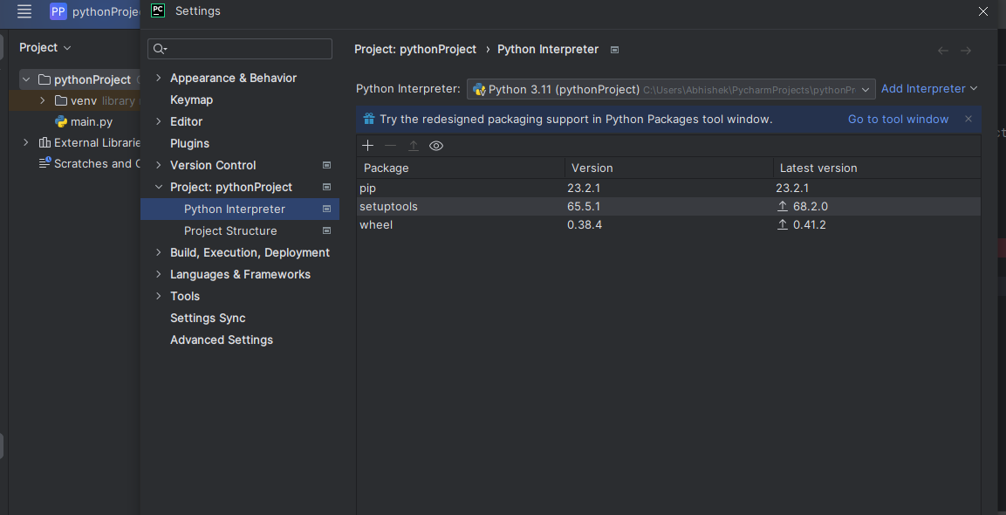

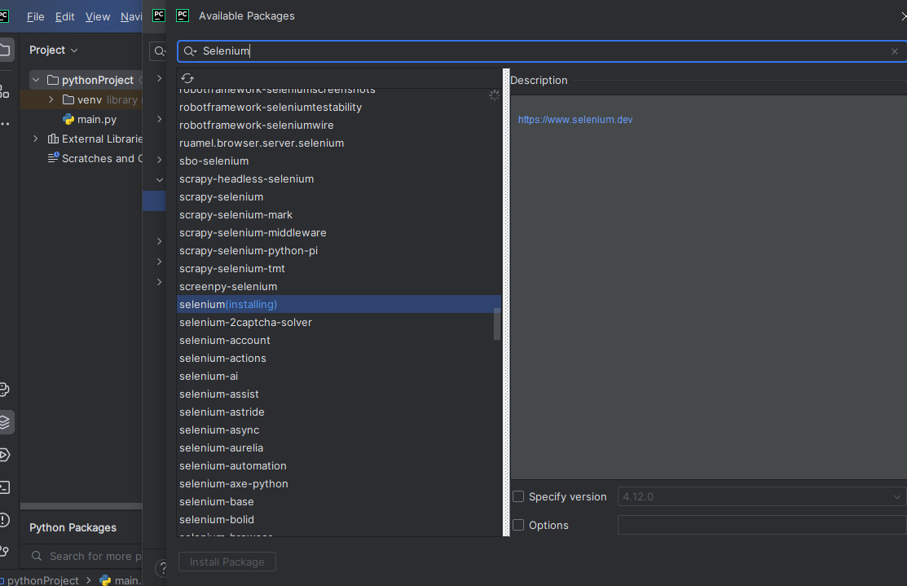

1. Create a file “Test.py” in your project file

from selenium import webdriver  
from selenium.webdriver.common import by  
from selenium.webdriver.common.by import By  
from selenium.webdriver.common.keys import Keys  
  
driver = webdriver.Chrome()  
  
driver.get("https://www.python.org")  
print("Your Page Title: "+driver.title)  
  
search_bar = driver.find_element(By.NAME, "q")  
  
search_bar.clear()  
search_bar.send_keys("getting started with python")  
search_bar.send_keys(Keys.RETURN)  
  
print("Your URL is :"+driver.current_url)  
  
driver.close()